**Adaptive Hysteresis Thresholding Segmentation Technique for Localizing the Breast Masses in the Curve Stitching Domain**

**Author: Bushra Mughal Nazeer Muhammad Muhammad Sharif**

**Method used in the paper:**

Presence of **pectoral muscle** in

breast mammogram highly affects the **detection process** of breast tumor.

A novel aspect of the proposed method is that the **curve stitching technique** is developed for removing of pectoral muscle. Following this, an **adaptive hysteresis thresholding is used for segmentation.** This hybrid technique is used for segmenting a breast region of digital mammogram with suppression of pectoral muscle.

**Results:**

**Sensitivity rate** is calculated here.

**96.6%** for the **MIAS dataset**

**96.4%** for the **DDSM dataset** as compared to existing methods.

**Proposed Method:**

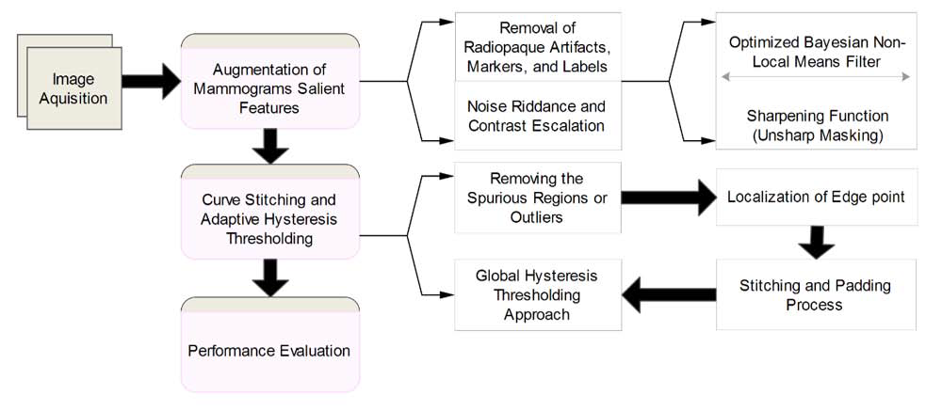

**On Data:**

Manual cropping to remove the artifacts.

**Enchancement Methods used**

Implement various **noise removal techniques top hat, bottom hat**, and

**optimized Bayesian non-local means filter** on our dataset for selection of an efficient noise removal technique. We found that **OBNLM** efficiently removes the noise while enhancing the edges and preserving the image structures [47, 48]. Each I be a preprocessed image which is normalized using I and then denoising operation f() is performed on I , inorder to get a noise free image

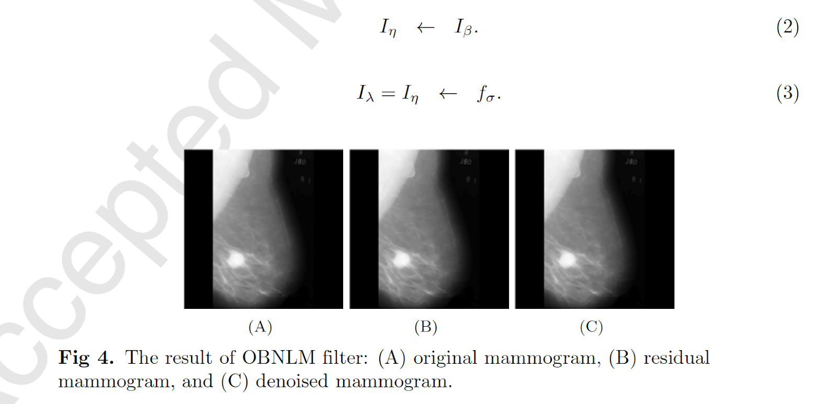

After **Implementation of optimized Bayesian non-local mean filter,** denoised mammogram I **needs to be sharpened for enhancing the features of mammogram**. A traditional sharpening filter is used in commercial software for un sharping, which was presented by Schreiber to improve the quality of pictures required for newspapers . This is banded on the principle of photographic masking to get the positive transparency of a low-contrast using the original negative data of the given mammogram. The desired mask is then incorporated with the original negative that produce the fuse data to crop the final pattern. This provide the sharpen outcome with an escalation trend. This is achieved by **detracting a blurred image from the original image. Unsharp masking indicate the high frequency details of mammogram, heightening a part of the band, which have the low signal to noise ratio (SNR). This often leads to noise amplification.**

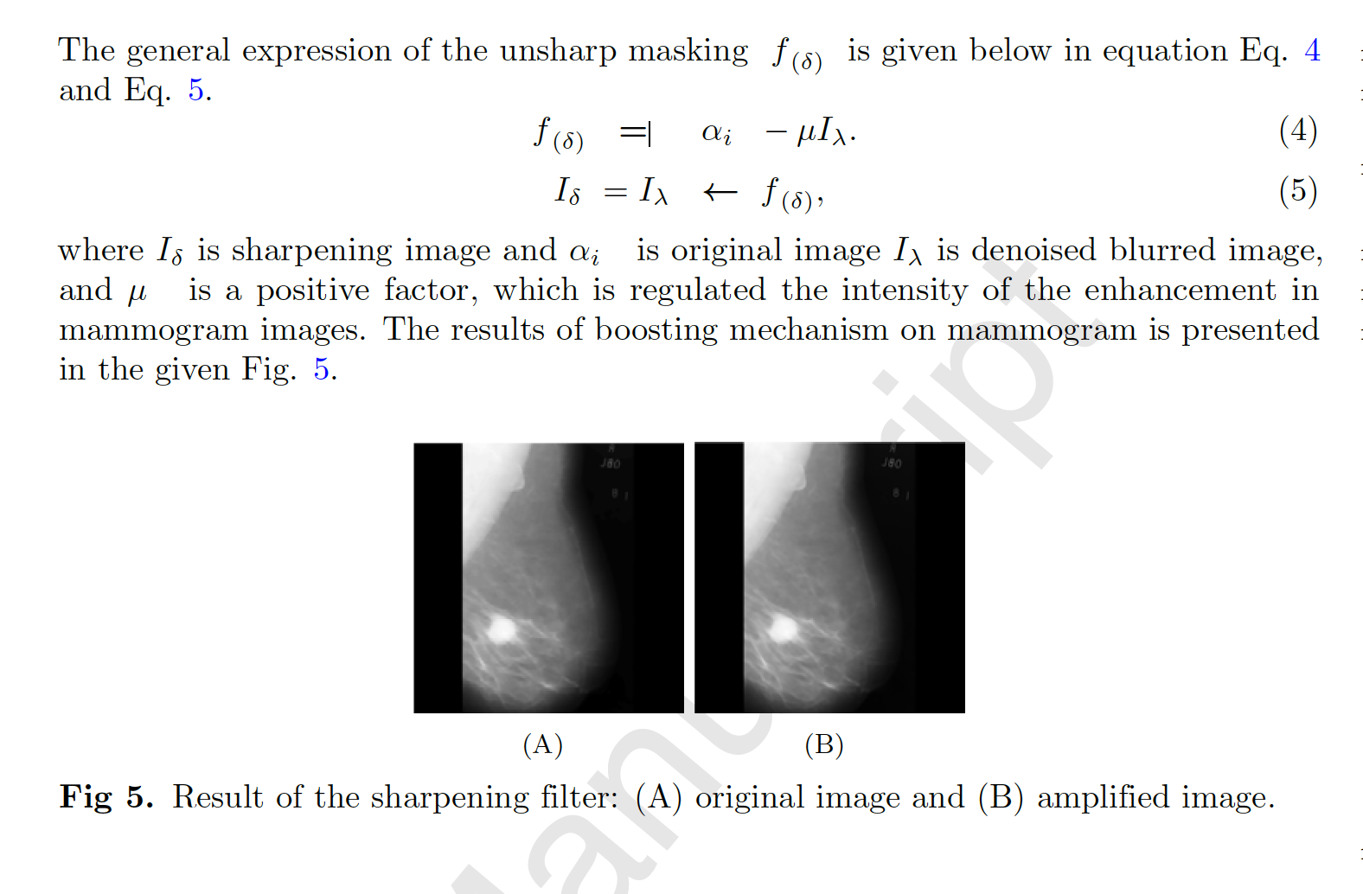

**Curve Stitching and Adaptive Hysteresis Thresholding**

* Removing the spurious regions or outliers
* Localization of Edge Point **Sobel Operator**

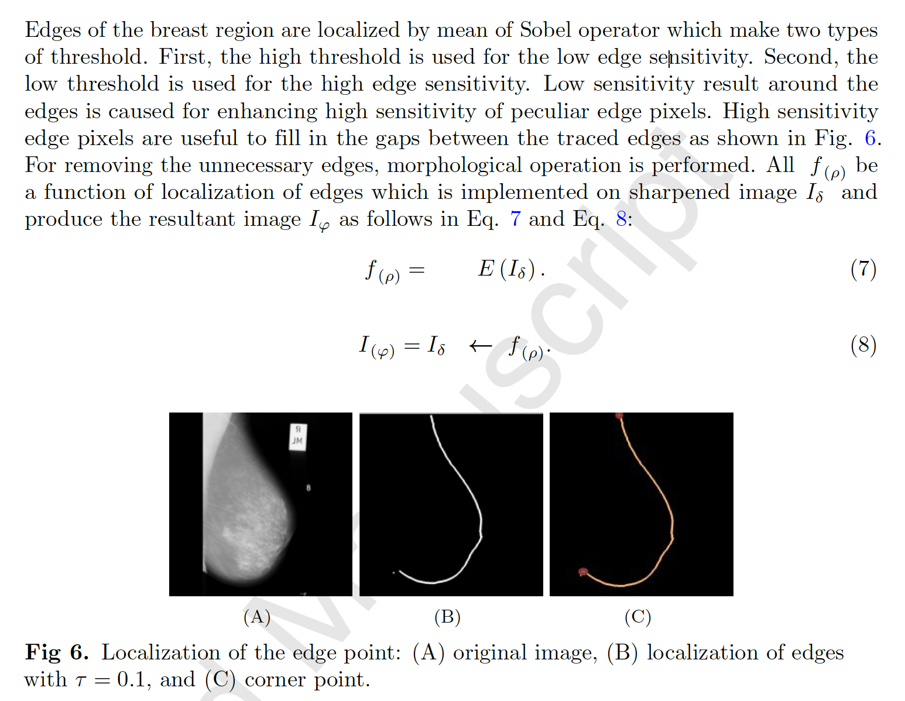

Stitching and Padding Process

Harris corner detector is used to locate the corner point of the broken breast boundary for stitching process

Global Hysteresis Thresholding Approach

Thresholding is used to generate a binary image from grey level values by setting all pixel's value with threshold  between the range of 0 to 1.

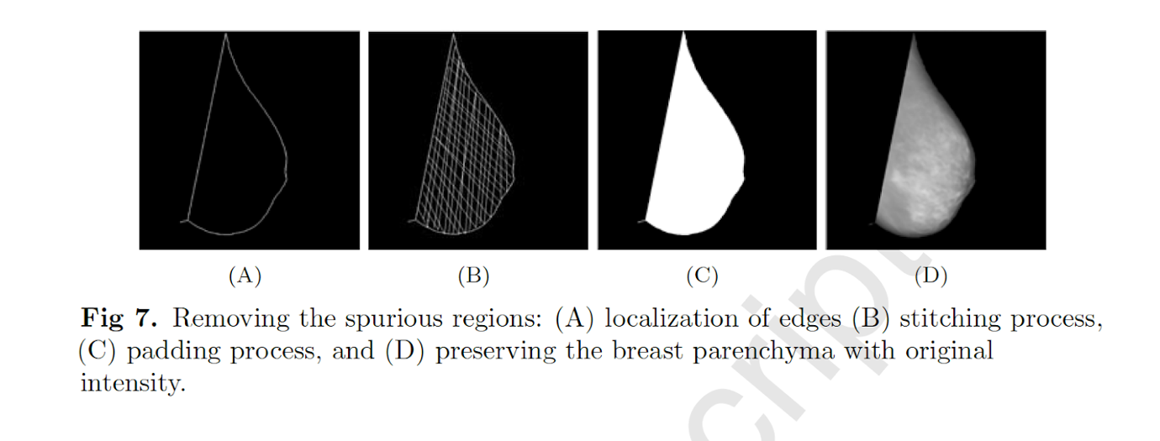

Adaptive hysteresis thresholding is used as 206

shown in I(l; k) =f; f(l; k) > threshold value

  0; f(l; k) <=threshold value

